Design A News Feed System

Problem Description

In this chapter, you are asked to design a news feed system. What is news feed? According to the Facebook help page, “News feed is the constantly updating list of stories in the middle of your home page. News Feed includes status updates, photos, videos, links, app activity, and likes from people, pages, and groups that you follow on Facebook/Instagram” .
This is a popular interview question. Similar questions commonly asked are to: design Facebook news feed, Instagram feed, Twitter timeline, etc.

Requirement Gathering

What are all the features does our application should have ?
Publish post
Generate news feed

What kind of application is this ?
Both web and app

How many daily users ?
All over the world 5 B people on internet among them most of them have the social media like FB or Instagram, twitter
Hence If I consider 80 % people uses social media then there are 4 B people
If I assume 80-20-1 rule then only 20% users are actively using social media 1B
For any of the platform like insta of face book we can assume 10M daily active users

AVG How many post users post every day ?
If 10M daily active users posts 5 post every day then 50M daily new post will be created
What are all the possible content type that post can contain ?
Image, Text, Comment
For simplicity we can assume only comment.

API and ERD Design
There will be 2 main action for this use case
- Publish the Post : when a user publishes a post, corresponding data is written into cache and database. A post is populated to her friends’ news feed.
- Newsfeed building: for simplicity, let us assume the news feed is built by aggregating friends’ posts in reverse chronological order.

If we consider above 2 main functions then main Schema involved here is
User : user_id(Long 8 byte), user_name(varchar(50) then 50 byte), user_email(100 byte), profile_id(8 byte), user_phone(10 byte) around 200 byte = 2B * 200 byte = 400GB
Profile : user_id, profile_id, profile_preference, profile_image, profile_description
Post : post_id, user_id, post_content_type, post_description, post_img_reference

Similarly we have other table also hence with single server mostly we can’t store all the Data hence we need to shard the data.

If we shard by post id then : For to show all the post made by user then we need to search in different shard ideally that is not good

We can shard by User id then : we need to balance the hot keys and balance the distribution
So that we can have all users post in one shard but one shard may contain more no of users post

API design :
Publish Post :
POST app/v1/post
Params
content
Token : like JWT which has user related information

News feed retrieval API :
GET app/v1/getFeed
Params
Cursor : current cursor position like current time
Token : like JWT which has user related information

Follow/Friend API :
PUT app/v1/[userId]/follow
Params :
userId : userId to follow/friend
Token : like JWT which has user related information

Functional Requirements
Core Requirements
- Users should be able to create posts.
- Users should be able to friend/follow people.
- Users should be able to view a feed of posts from people they follow, in chronological order.

Non-Functional Requirements
Core Requirements
- The system should be highly available (prioritizing availability over consistency). We'll tolerate up to 1 minute of post staleness (eventual consistency).
- Posting and viewing the feed should be fast, returning in < 500ms.
- The system should be able to handle a massive number of users (2B).
- Users should be able to follow an unlimited number of users, users should be able to be followed by an unlimited number of users.

1. Users should be able to create posts.
This is the first use case that user can create posts that we can use for news feed generation.
Firstly we will look at simple way of creating post
We can skip the caching aspect of the pattern since we'll get to that later. By having the API gateway and load balancer, we can scale up our service with more traffic by adding additional hosts

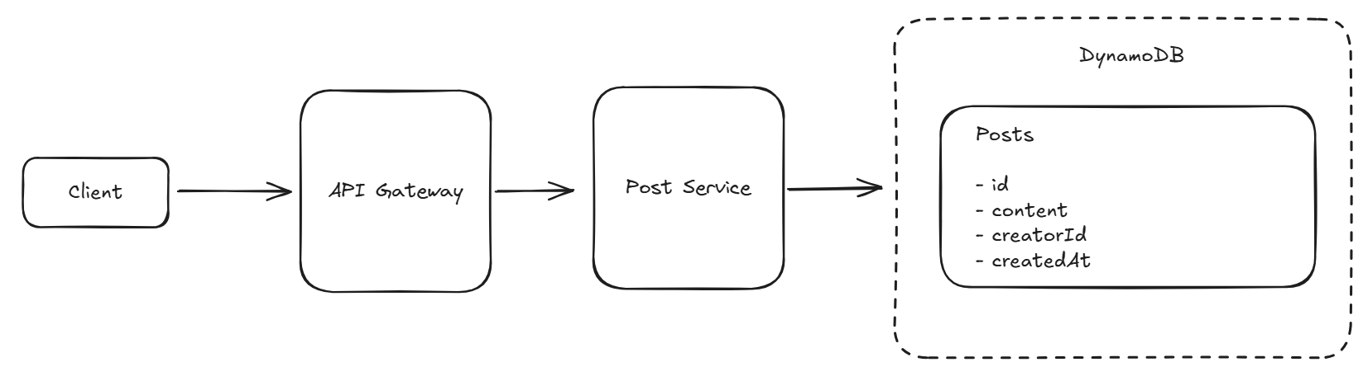

2. Users should be able to friend/follow people.

We need to create graph like structure between 2 users with friend or follow relationship
Usually we use Graph DB.(Neo4J). We can use Follow schema like following_id, followed_id

So the HLD diagram will look like
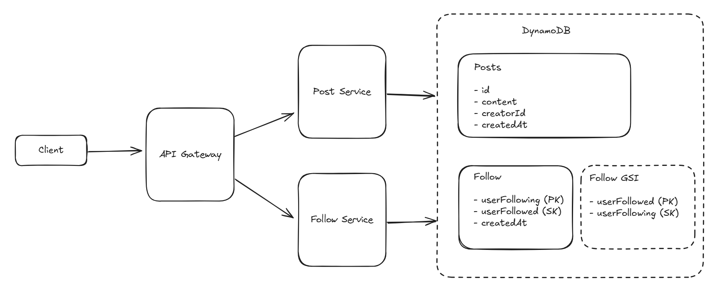

3. Users should be able to view a feed of posts from people they follow.

The challenge of viewing a feed of posts can be broken down into steps, which we can do with our present design with only a few changes:
- First, we get all of the users who a given user is following.
- Next, we get all of the posts from those users.
- Finally, we sort all those posts by time and return them to the user.
We'll start by adding a feed service to do this work. It's going to be read-heavy and have very different query patterns than the Post and Follow services, so separating it out makes sense.

If I start creating feed when user starts scrolling down, the news feed then it might take more time as we need to do all above mentioned 3 steps.

But what if I do this when I am writing (publishing the posts)
It will be like, for each users we will be having tuples user_id(reference to who posted 8byte), post_id(reference to what is being posted 8byte) so roughly it will be 20 bytes for each value but this might contain the many tuples. So If I need to cache top 5000 post(assuming user has 5000 friends and each one of them posted) then for each user cache size will be 100kB. And if I have 1TB of Hard-drive then 1TB/100KB = 10M users I can cache it easily on single server

This model is PUSH model. When user publish the post asynchronously add that to message Queue then fetch the followers or friends list of them and update theirs news feed cache.

But most of the users are not active users for them we can compute the news feed on the go when refresh the home page. For them we will use pull model. We can have mapping like which users are active and passive users and for active users we can use push model and passive users we can use pull model. This will help us to solve celebrity problems those have Millions of followers. In that case it is nearly difficult to update each followers news feed. We need more workers also in push model.
So news feed cache eviction policy will be TTL like last 30days post only we maintain for the users in cache the same this will be used and Invalidation policy. And all this things suggest that it will be Write-Around cache policy as we choose Availability over immediate consistency (Eventual Consistency works fine here with 1min latency)

Hence complete system Design will look something like this
